**Wireframes/Screen Layouts**

**Machine Learning and Spaced Repetition Systems for Predicting Foreign Language Vocabulary Test Scores**

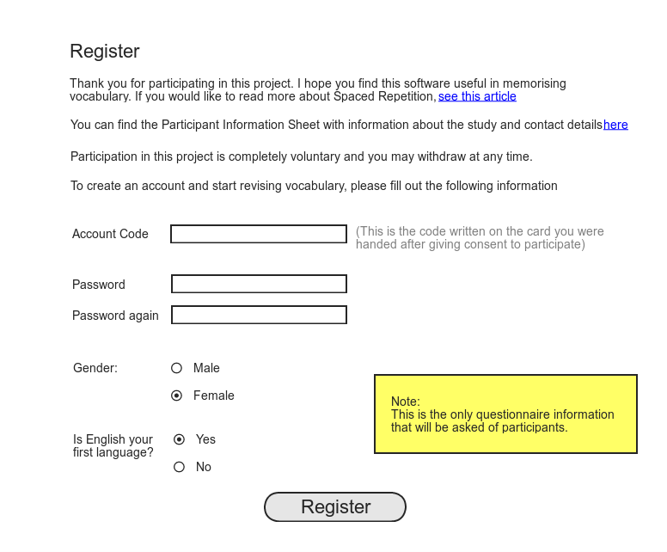

Figure - Registration Page. After participants have signed a consent form, they are randomly handed a card with a web address and a unique code written on it. When the participant accesses the web address, this page will be displayed requesting information from the participant.

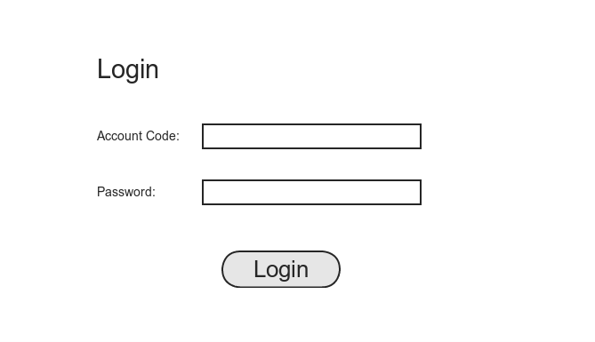

Figure - Login Screen

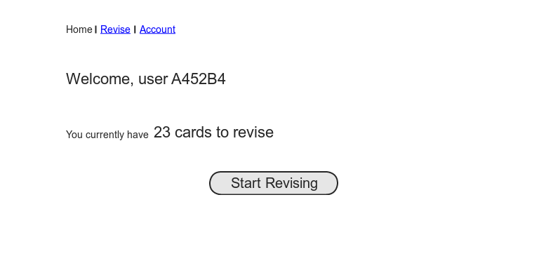

Figure - The Home Page. Displays the number of cards currently due for revision.

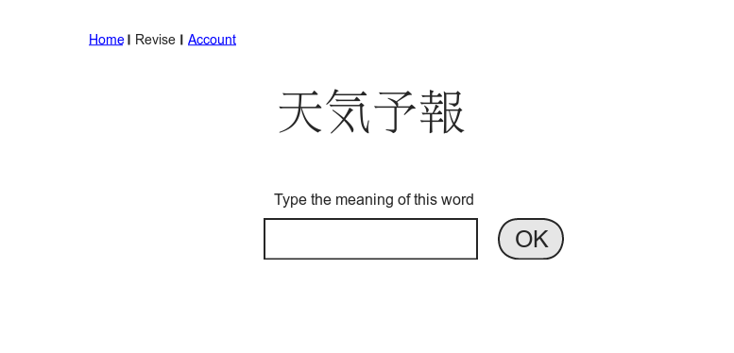

Figure - Revision Screen 1

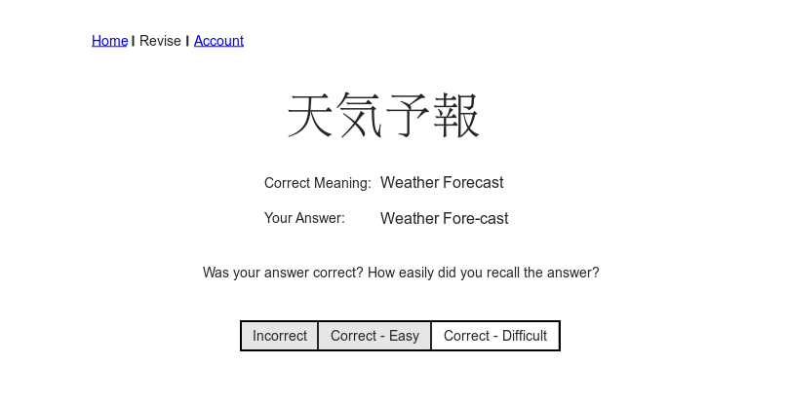

Figure - Revision Screen 2

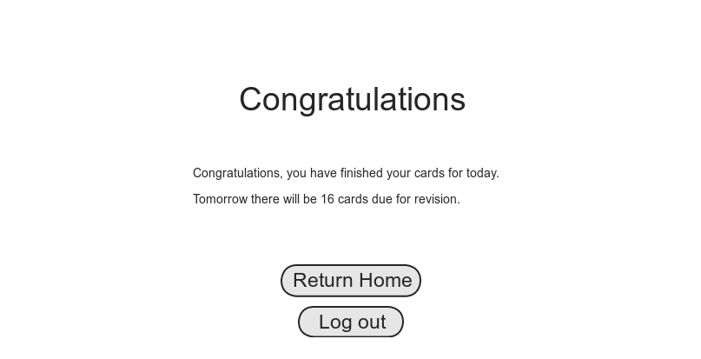

Figure - Revision Complete Screen

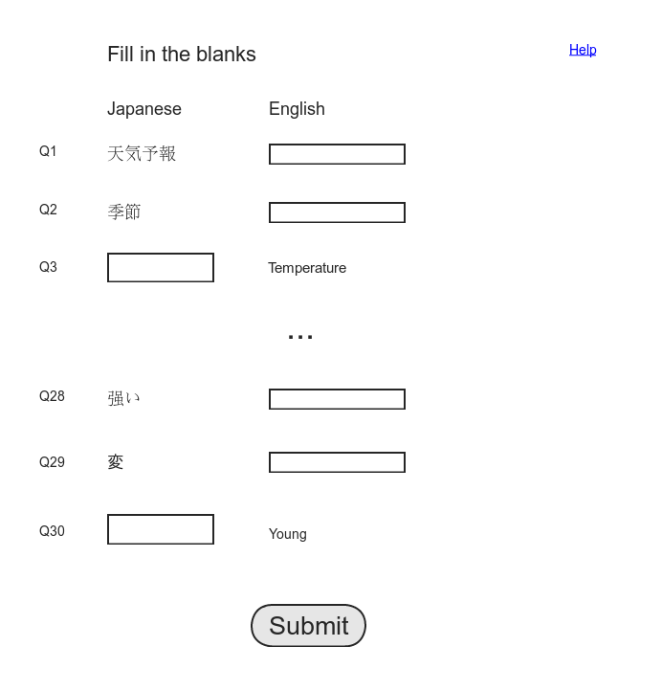

Figure - Quiz Screen

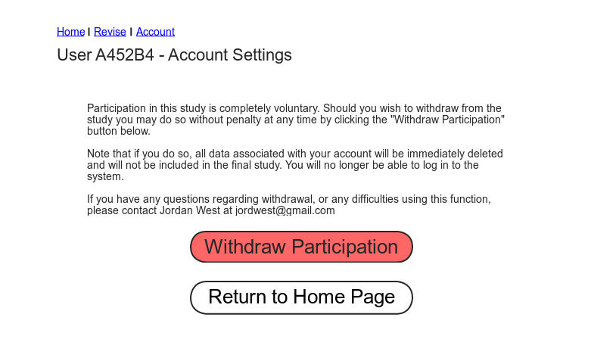

Figure - Withdrawal of Participation Screen

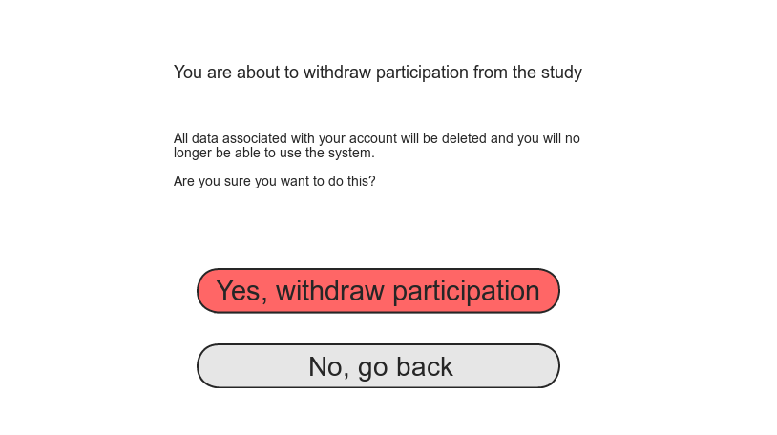

Figure - Withdrawal of Participation confirmation